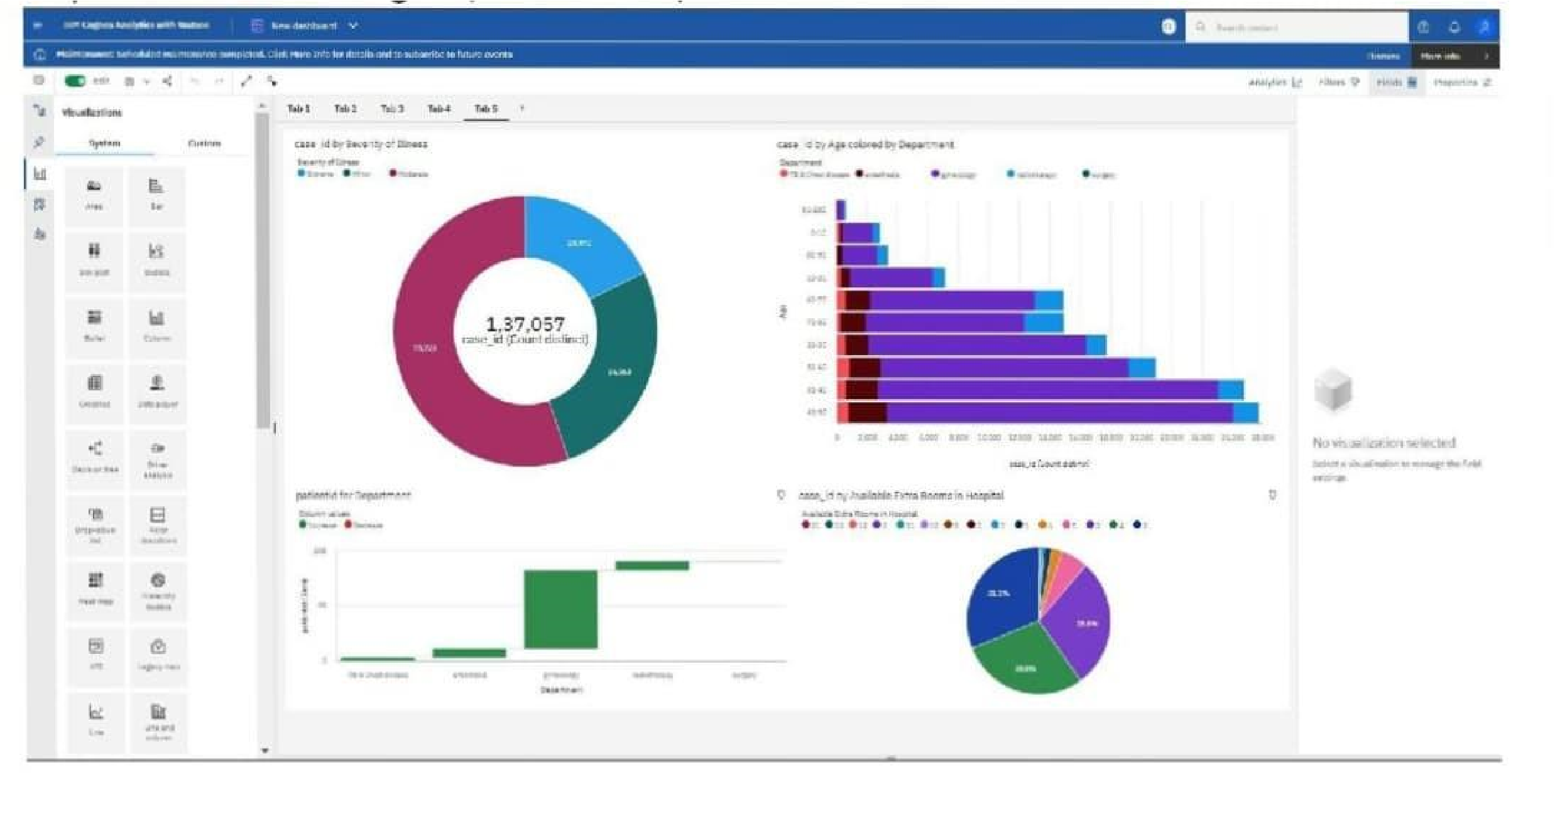Dashboard Showing Pie, Stacked Bar, Water fall And Pie Charts

